6. Write Steps with Screenshot for creating Project, epic, Story, Sprint.

Step 1 :

Visit [**https://www.atlassian.com/software/jira**](https://www.atlassian.com/software/jira)and Login to **JIRA** Software.

Step 2 :

Click on  **“Create New Project”**.

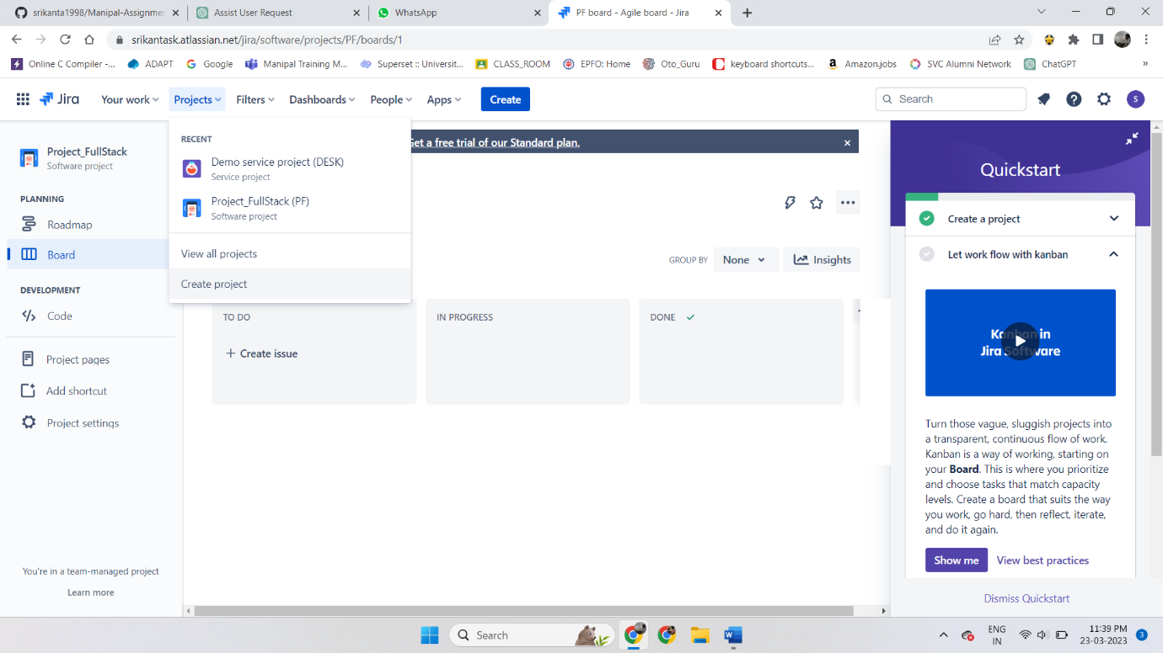

Step 3 :

Now select **Scrum Template** from the Options displayed.

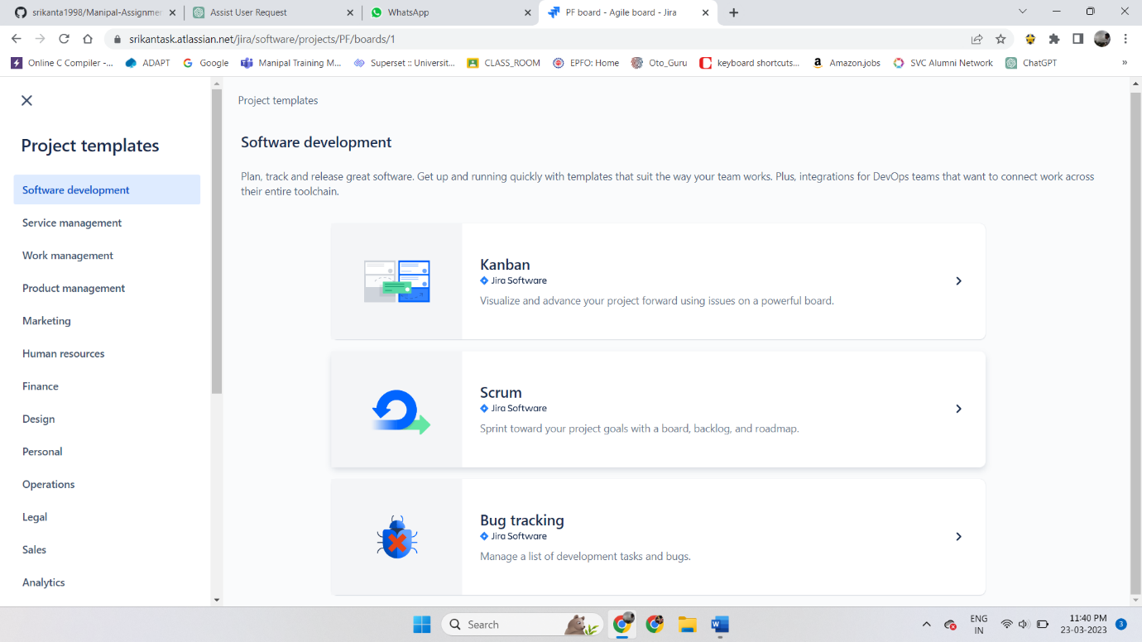

Step 4 :

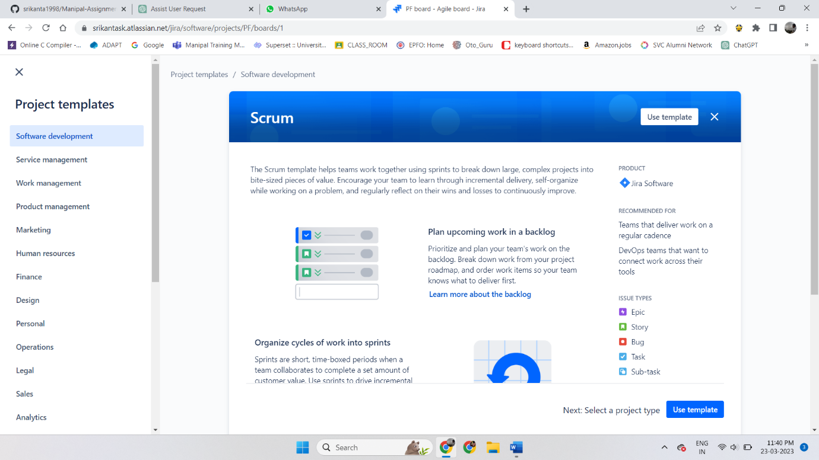 Now Click on **Use Template**.

Step 5 :

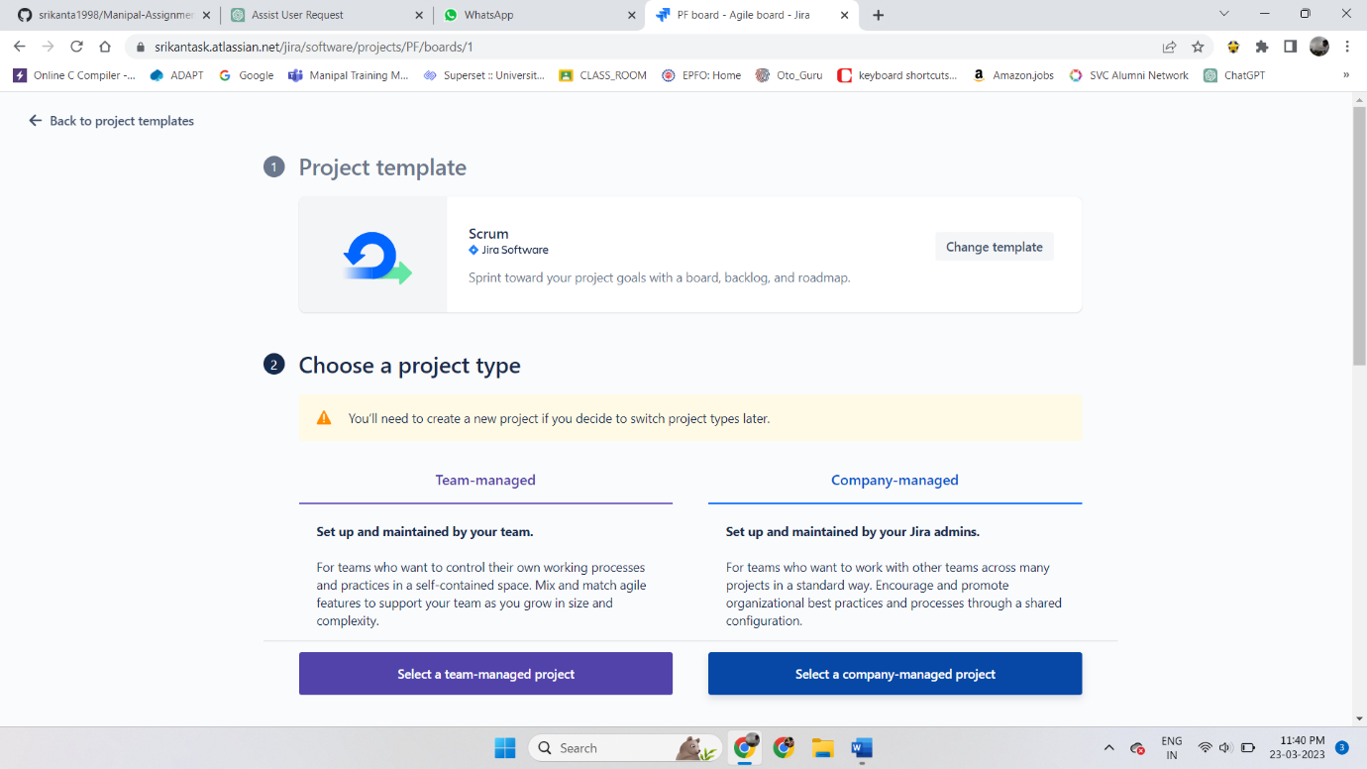 Select **project type** (I selected company managed project).

Step 6 :

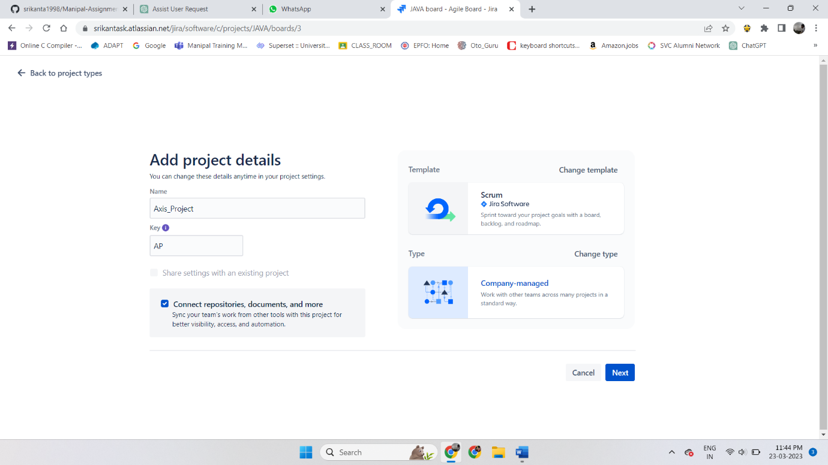 Enter **project name** and click on next to create project.

Step 7 :

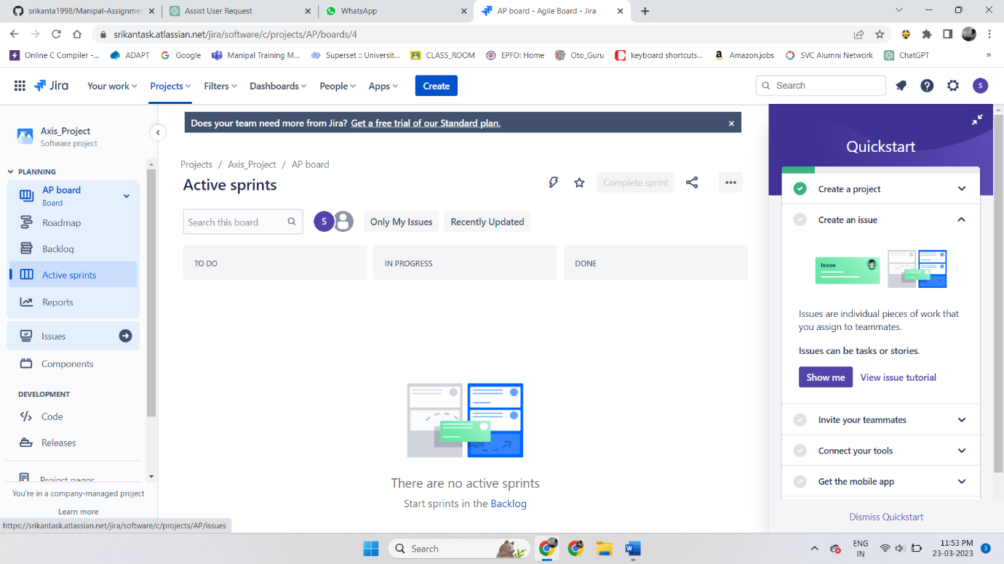 Click on **Issues** in the **Left** side **navigation bar**.

Step 8 :

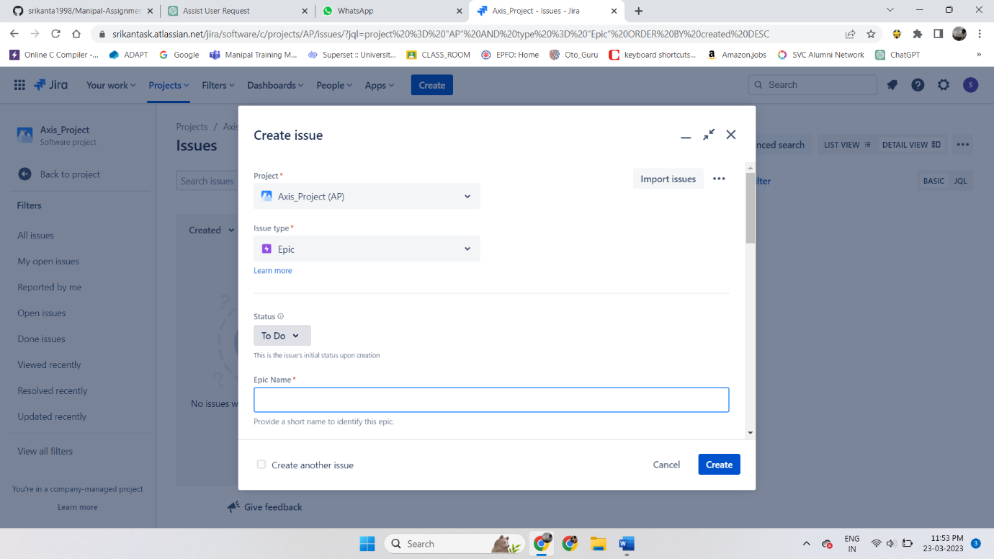Now click on **Create** and select **Issue** type as **“Epic”**.

Step 9 :

 Again click on **Create** and select **Issue** type as **“Story”**.

Step 10 :

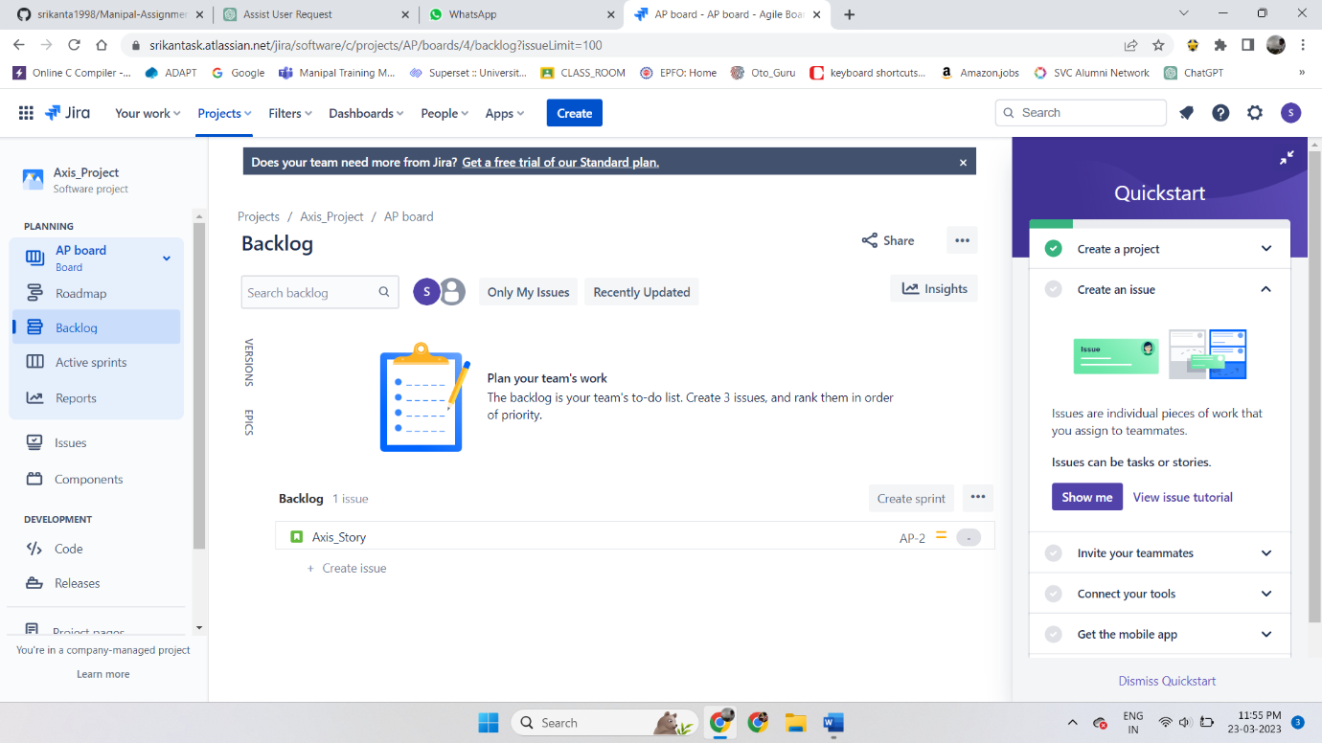 Now click on the **left** side **navigation bar** and select **Backlogs**.

Step 11 :

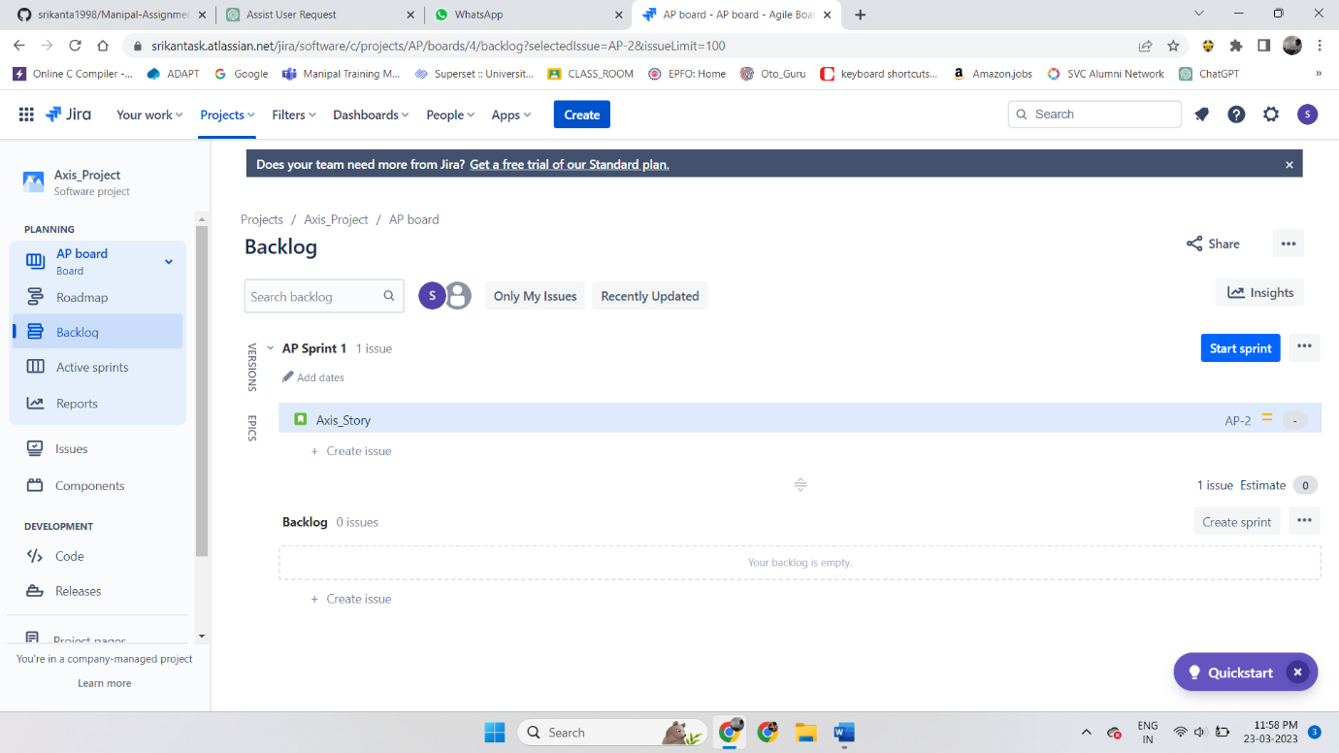Click on **create Sprint** and then drag your **product backlogs** to the **sprint option**. Then after Click **Start Sprint**.

Step 12 :

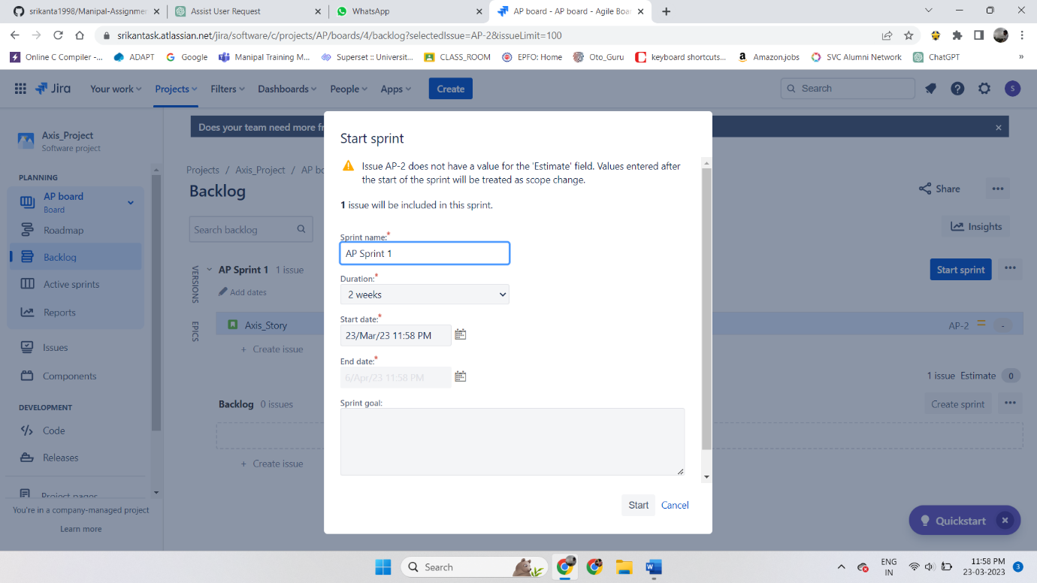 Here, add the **duration** and click start.